NETWORKING LAB MANUAL

VLAN CONFIGURATION
Inter⁻SwitchVLANSegmentationusingTrunking
Cisco Packet Tracer Simulation Project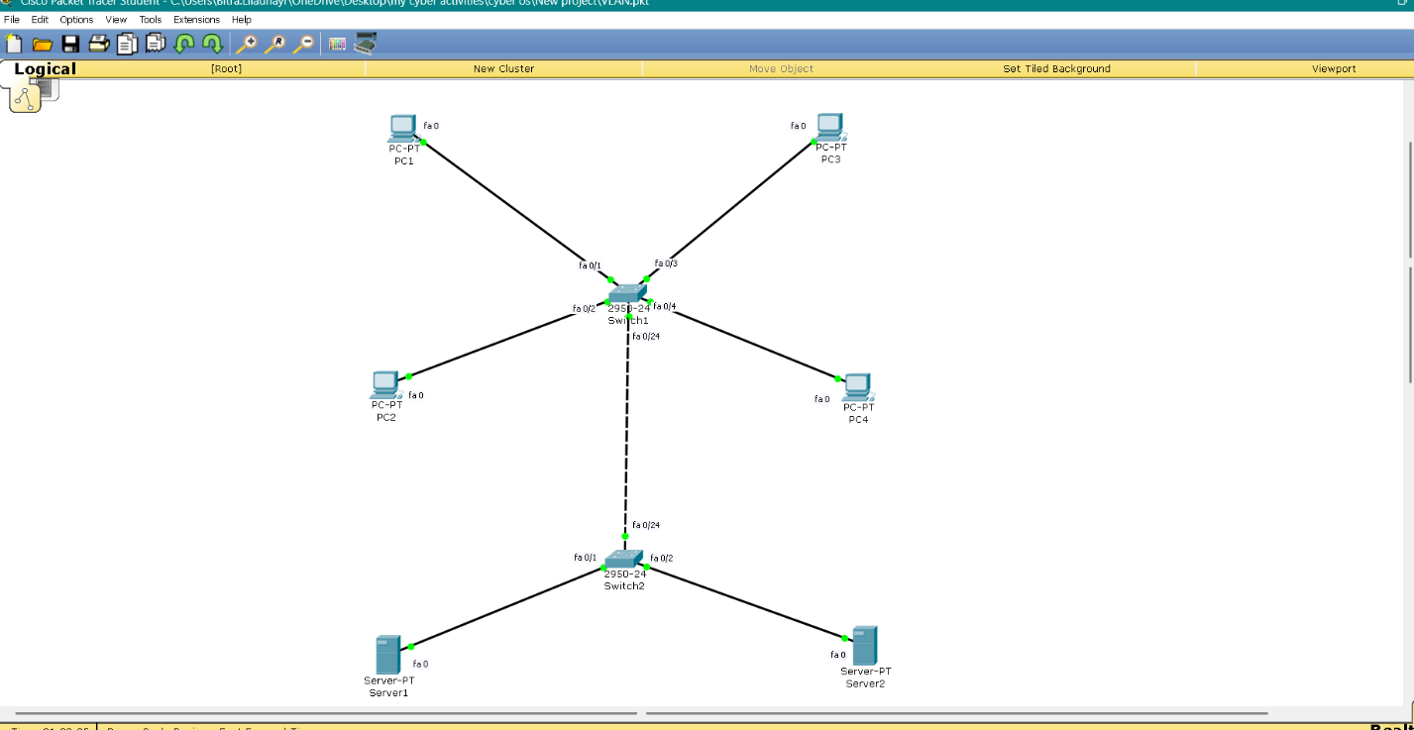
Field | Details
Project Title | VLAN Segmentation & Inter-Switch Trunk Configuration
Tool Used | Cisco Packet Tracer
Devices Used | 2 x Cisco 2950-24 Switches, 4 x PCs, 2 x Servers
VLANs Configured | VLAN 10 (Sales) & VLAN 20 (IT)
Student Name | BITRA LILADHAYR
Class / Roll No. | 24B21A4617
Submission Date | 20/06/2026

1. Aim

To design, configure, and verify a Virtual LAN (VLAN) network across two interconnected Cisco switches using Cisco Packet Tracer, demonstrating VLAN segmentation, access port assignment, and inter-switch trunking.

2. Objectives

- Understand the concept of VLANs and their role in network segmentation.
- Configure two separate VLANs (Sales and IT) on Cisco switches.
- Assign access ports to the correct VLAN for connected end devices.
- Configure a trunk link to extend VLANs across multiple switches.
- Verify VLAN configuration and connectivity using show commands and ping tests.
- Analyze and troubleshoot common VLAN/trunk configuration errors.

3. Theory

3.1 What is a VLAN?
A Virtual Local Area Network (VLAN) is a logical grouping of devices on a network that allows them to communicate as if they were on the same physical LAN segment, regardless of their actual physical location. VLANs improve network performance, security, and manageability by isolating broadcast traffic between groups of devices.

3.2 Access Ports vs Trunk Ports
Port Type | Purpose |  |  |  |  | VLANs Carried
Access Port | Connects servers | end devices | such | as | PCs and | Carries traffic exactly 1 VLAN | for
Trunk Port | Connects router links | switch-to-switch |  | or | switch-to- | Carries traffic for (or tagged) VLANs | ALL

3.3 VLAN Tagging (802.1Q)
When a frame crosses a trunk link, the switch inserts an 802.1Q tag into the Ethernet frame header identifying which VLAN the frame belongs to. The receiving switch reads this tag and forwards the frame only to ports that are members of that VLAN, then strips the tag before delivering it to an access port.

4. Software & Equipment Required
Item | Quantity | Notes
Cisco Packet Tracer | 1 instance | Version 8.0 or later recommended
Switch (2950-24) | 2 | Switch1 and Switch2
PC-PT (PC) | 4 | PC1, PC2, PC3, PC4
Server-PT | 2 | Server1, Server2
Copper Straight-Through Cable | 6 | PC/Server to Switch links
Copper Straight-Through Cable (Trunk) | 1 | Switch1 to Switch2 link

5. Network Design

5.1 Topology Diagram
The topology below shows two switches interconnected via a trunk link. Switch1 hosts PC1, PC2, and Server1 (VLAN 10 – Sales). Switch2 hosts PC3, PC4, and Server2 (VLAN 20 – IT).

[ INSERT SCREENSHOT HERE ]
Figure5.1—FullnetworktopologyinCiscoPacketTracer

5.2 VLAN & IP Addressing Plan
Device | Switch |  | Port | VLAN |  | IP Address |  | Subnet Mask
PC1 | Switch1 |  | Fa0/1 | 10 – Sales |  | 192.168.1.1 |  | 25.255.255.0
PC2 | Switch1 |  | Fa0/2 | 10 – Sales |  | 192.168.1.2 |  | 255.255.255.0
Server1 | Switch1 |  | Fa0/3 | 10 – Sales |  | 192.168.1.100 |  | 255.255.255.0
PC3 | Switch2 |  | Fa0/1 | 20 – IT |  | 192.168.2.3 |  | 255.255.255.0
PC4 | Switch2 |  | Fa0/2 | 20 – IT |  | 192.168.2.4 |  | 255.255.255.0
Server2 | Switch2 |  | Fa0/3 | 20 – IT |  | 192.168.2.100 |  | 255.255.255.0
Switch1 Port |  | Switch2 Port |  |  | Mode |  | VLANs Allowed
Fa0/24 |  | Fa0/24 |  |  | Trunk (802.1Q) |  | VLAN 1, 10, 20 (all)

6. Procedure

6.1 Step 1 — Build the Topology
- Open Cisco Packet Tracer and place 2 switches, 4 PCs, and 2 servers on the workspace.
- Connect PC1, PC2, Server1 to Switch1 and PC3, PC4, Server2 to Switch2 using Copper Straight-Through cables.
- Connect Switch1 (Fa0/24) to Switch2 (Fa0/24) using a Copper Straight-Through cable for the trunk link
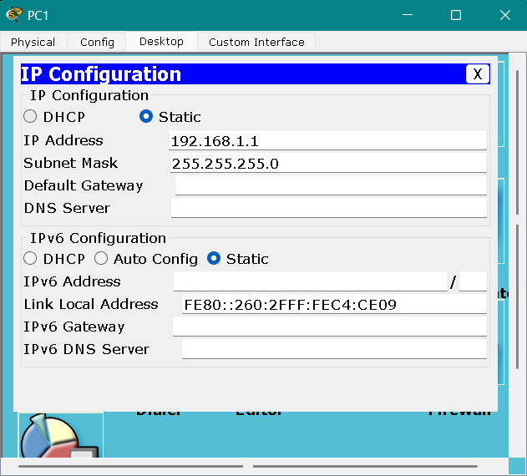
k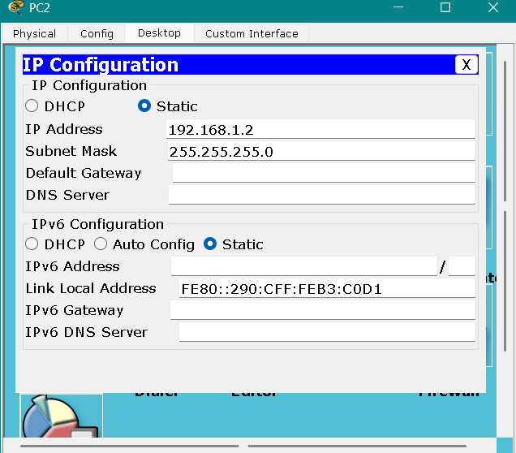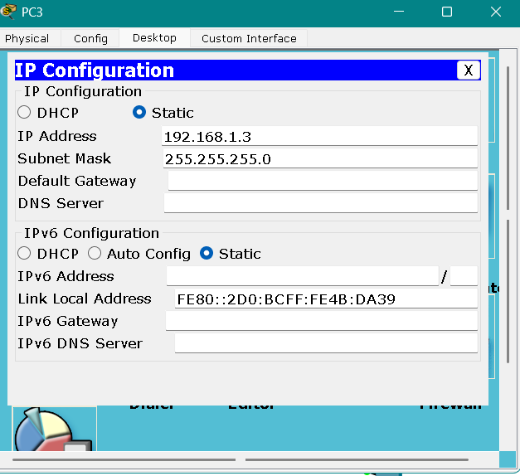

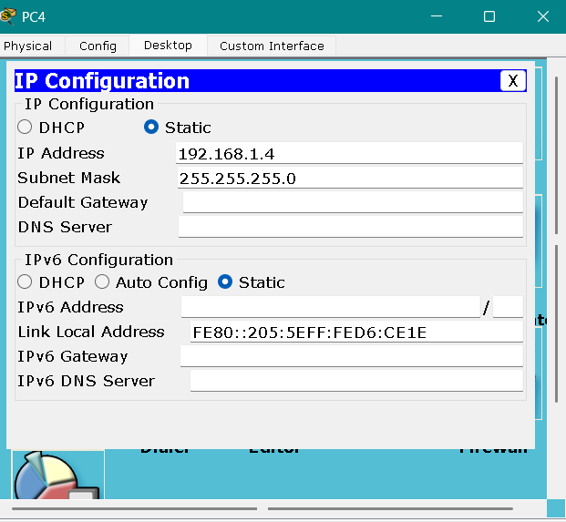

6.2 Step 2 — Assign IP Addresses to End Devices
- Click each PC/Server → Desktop tab → IP Configuration.
- Enter the IP Address and Subnet Mask as per the addressing plan in Section 5.2.

[ INSERT SCREENSHOT HERE ]
Figure6.2—IPConfigurationwindowforPC1

6.3 Step 3 — Configure Switch1 (VLANs & Access Ports)
Switch> enable
Switch# configure terminal
Switch(config)# hostname SW1
SW1(config)# vlan 10
SW1(config-vlan)# name Sales
SW1(config-vlan)# exit
SW1(config)# vlan 20
SW1(config-vlan)# name IT
SW1(config-vlan)# exit
SW1(config)# interface fa0/1
SW1(config-if)# switchport mode access
SW1(config-if)# switchport access vlan 10
SW1(config-if)# exit
SW1(config)# interface fa0/2
SW1(config-if)# switchport mode access
SW1(config-if)# switchport access vlan 10
SW1(config-if)# exit

6.4 Step 4 — Configure the Trunk Port on Switch1
SW1(config)# interface fa0/24
SW1(config-if)# switchport mode trunk
SW1(config-if)# exit
SW1(config)# exit
SW1# write memory

6.5 Step 5 — Configure Switch2 (VLANs, Access Ports & Trunk)
Switch> enable
Switch# configure terminal
Switch(config)# hostname SW2
SW2(config)# vlan 10
SW2(config-vlan)# name Sales
SW2(config-vlan)# exit
SW2(config)# vlan 20
SW2(config-vlan)# name IT
SW2(config-vlan)# exit
SW2(config)# interface fa0/1
SW2(config-if)# switchport mode access
SW2(config-if)# switchport access vlan 20
SW2(config-if)# exit
SW2(config)# interface fa0/2
SW2(config-if)# switchport mode access
SW2(config-if)# switchport access vlan 20
SW2(config-if)# exit
SW2(config)# interface fa0/24
SW2(config-if)# switchport mode trunk
SW2(config-if)# exit
SW2(config)# exit
SW2# write memory
[ INSERT SCREENSHOT HERE ]
Figure6.5—CLIconfigurationcommandsexecutedonSwitch2

7. Verification & Testing

7.1 Verify VLAN Database
Run the following command on both switches to confirm VLANs were created and the correct ports were assigned:
SW1# show vlan
SW2# show vlan

[ INSERT SCREENSHOT HERE ]
Figure7.1—'showvlan'outputonSwitch1confirmingportassignment

7.2 Verify Trunk Link Status
Run the following command on both switches to confirm the trunk is active and carrying all VLANs:
SW1# show interfaces trunk
SW2# show interfaces trunk

[ INSERT SCREENSHOT HERE ]
Figure7.2—'showinterfacestrunk'outputconfirmingFa0/24istrunking

7.3 Connectivity Testing (Ping)
From each PC's Command Prompt (Desktop tab), the following ping tests were performed:
Test | Source → Destination | Same VLAN? | Expected Result | Actual Result
1 | PC1 (192.168.1.1) → PC2 (192.168.1.2) | Yes (VLAN 10) | Success | ________
2 | PC3 (192.168.2.3) → PC4 (192.168.2.4) | Yes (VLAN 20) | Success | ________
3 | PC1 (192.168.1.1) → PC3 (192.168.2.3) | No (10 vs 20) | Request timed out | ________
4 | PC1 (192.168.1.1) → Server1  (192.168.1.100) | Yes (VLAN 10) | Success | ________

8. Observations / Results

- Devices within the same VLAN communicated successfully despite being on different physical switches, confirming the trunk link correctly carried tagged VLAN traffic.
- Devices in different VLANs (VLAN 10 and VLAN 20) could not communicate, confirming that VLANs successfully isolate broadcast domains at Layer 2.
- The 'show vlan' command confirmed each access port was mapped to its intended VLAN.
- The 'show interfaces trunk' command confirmed Fa0/24 on both switches was operating in trunk mode, allowing all VLANs to pass between switches.

9. Troubleshooting Notes
Common issues encountered during this lab and their resolutions are summarized below — useful for any student repeating this exercise.
Issue Observed |  | Likely Cause | Resolution
Link between switches shows red |  | Trunk not configured on one or both ends, or wrong port used | Re-enter 'switchport mode trunk' on the exact connected port on both switches; verify with 'show interfaces trunk'
Ping fails between sameVLAN PCs on different  switches |  | Port not assigned to VLAN; trunk not passing that VLAN | Check 'show vlan' on both switches; re-assign access port to correct VLAN
'show vlan' lists no under VLAN 10/20 | ports | Access port commands not executed or executed on  wrong interface | Re-enter switchport mode acces switchport access vlan <id> on correct Fa0/x interface | s + the
Command rejected  'Invalid input detected' | with | Typing error in command (e.g.  missing letter) | Retype the command carefully, 'show' not 'how' | e.g.

10. Conclusion

This project successfully demonstrated the design and configuration of VLANs across two interconnected Cisco switches using Packet Tracer. By creating VLAN 10 (Sales) and VLAN 20 (IT), assigning access ports, and configuring an 802.1Q trunk link between switches, devices belonging to the same VLAN were able to communicate across switch boundaries, while devices in different VLANs remained isolated — confirming correct VLAN segmentation and trunk operation. This exercise reinforces the practical importance of VLANs in improving network security, reducing broadcast traffic, and enabling scalable, logically segmented enterprise networks.

11. Learning Outcomes

- Ability to create and name VLANs on a Cisco switch.
- Ability to assign switchports to specific VLANs as access ports.
- Ability to configure and verify an 802.1Q trunk link between two switches.
- Ability to use ping and show commands to verify and troubleshoot VLAN connectivity.
- Understanding of how VLANs isolate broadcast domains at Layer 2 of the OSI model.

.3 Trunk Link

